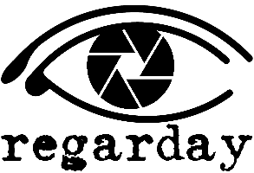
Thank you for scheduling your home photo shoot with Regarday. We want to provide you with the best photos of your home possible, and be in and out or your home in a timely manner. In order to do this, we will need your help. Here is a check list to complete prior to our arrival to be sure your home will be
“Photo Ready.”
Also, photographing homes can be a tricky job...and it can be even more tricky if we have to track the whereabouts of people and pets while we are shooting. We politely request that if possible you leave or wait outside while we do our shoot. Think of it as a dry run for when showing time comes :-) We are always happy to call or text when we are finished.
Photos are the first thing a prospective buyer will see of your home, so be thorough and have all items completed before the scheduled time of your shoot. Thank you!

The Regarday Team
Interior:
  - Turn all lights on, including lamps, replace all non-working bulbs with like colors.
  - Turn all fans off.
  - Put away and out of sight, all dishes, trashcans, small appliances and paper towel holders.
  - Open curtains and make all beds.
  - Put pet food dishes, litterboxes, crates, beds and toys away and out of sight.
  - Put all toilet seats down.
  - Remove all personal items from bathroom countertops. Remove all soiled towels and clothing.
  - Remove trash cans, toilet brushes and plungers from bathroom.
  - Tuck away power cords and wires.
  - Remove magnets and papers from refrigerator.
  - Declutter all rooms and have rooms free of as many small items as possible.
  - Dust, vacuum and clean windows and mirrors.
Exterior:
  - Remove all toys, trash cans, hoses and lawn tools from yard.
  - Remove vehicles from driveway, and if possible don’t park directly in front of house.
  - Sweep porches, decks, driveway and sidewalks.
  - Clean pool and remove all pool toys and equipment.
  - Remove clutter from deck and under deck and porches.

Your photo shoot is scheduled for:________________________ ________am/pm

Note: Moving items from room to room is not possible with the 3D virtual tour.

